Ejercicio 1

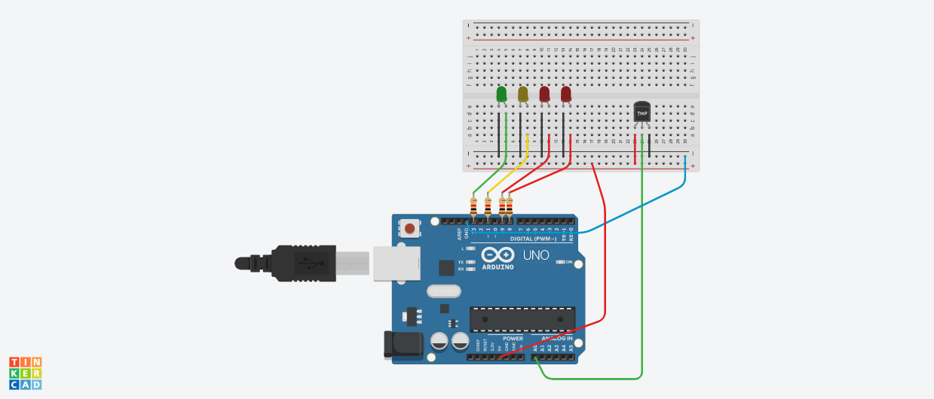

int tem = 0;

int cels = 0;

void setup()

{

pinMode(A0, INPUT);

pinMode(13, OUTPUT);

pinMode(11, OUTPUT);

pinMode(9, OUTPUT);

pinMode(8, OUTPUT);

digitalWrite(13, LOW);

digitalWrite(11, LOW);

digitalWrite(9, LOW);

digitalWrite(8, LOW);

}

void loop()

{

tem = 40;

cels = cels = map(((analogRead(A0) - 20) \* 3.04), 0, 1023, -40, 125);

if (cels <= 24) {

digitalWrite(13, HIGH);

digitalWrite(11, LOW);

digitalWrite(9, LOW);

digitalWrite(8, LOW);

}

if (cels > 24 && cels <= 27) {

digitalWrite(13, LOW);

digitalWrite(11, HIGH);

digitalWrite(9, LOW);

digitalWrite(8, LOW);

}

if (cels >= 28 && cels <= 33) {

digitalWrite(13, LOW);

digitalWrite(11, LOW);

digitalWrite(9, HIGH);

digitalWrite(8, LOW);

}

if (cels >= 34) {

digitalWrite(13, LOW);

digitalWrite(11, LOW);

digitalWrite(9, HIGH);

digitalWrite(8, HIGH);

}

}

Ejercicio 2

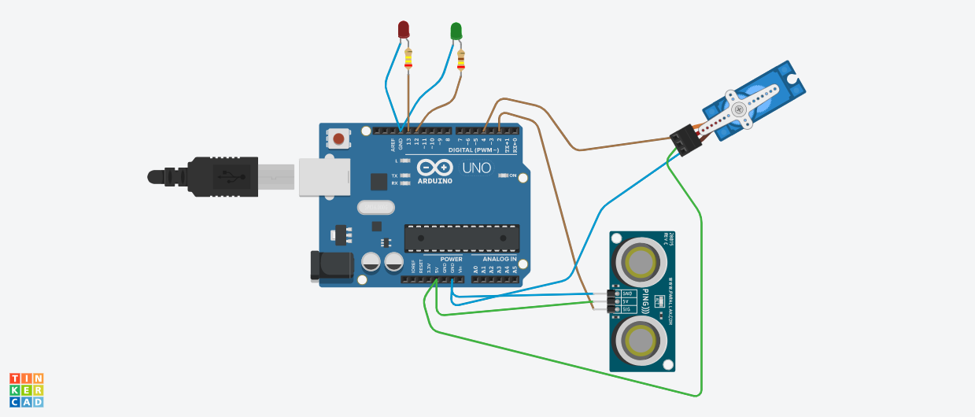

Servo servo1;

int inches = 0;

int dist = 0;

int position = 0;

long readUltrasonicDistance(int pin)

{

pinMode(pin, OUTPUT);

digitalWrite(pin, LOW);

delayMicroseconds(2);

digitalWrite(pin, HIGH);

delayMicroseconds(10);

digitalWrite(pin, LOW);

pinMode(pin, INPUT);

return pulseIn(pin, HIGH);

}

void setup()

{

pinMode(4, OUTPUT);

pinMode(13, OUTPUT);

pinMode(12, OUTPUT);

pinMode(2, INPUT);

Serial.begin(9600);

servo1.attach(2);

}

void loop()

{

dist = 0.01723 \* readUltrasonicDistance(2);

{ if (dist <=20)

digitalWrite(13, HIGH);

digitalWrite(12, LOW);

delay(5000);

digitalWrite(13, LOW);

digitalWrite(12, HIGH);

delay(5000);

for (position = 0; position <= 180; position += 1) {

Serial.println(position);

servo1.write(position);

delay(5000);

}

for (position = 180; position >= 0; position -= 1) {

Serial.println(position);

servo1.write(position);

delay(5000);

}

digitalWrite(13, LOW);

digitalWrite(12, LOW);

delay(500);

} }